Abdullah Alakbarli

Teacher: Şükür İbadov

Task 2

I changed the name of table here:



I changed the column name of the table here:

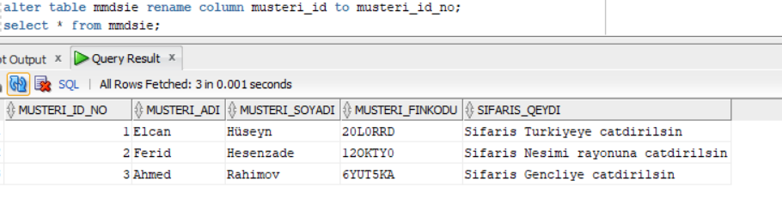

I added new column here:

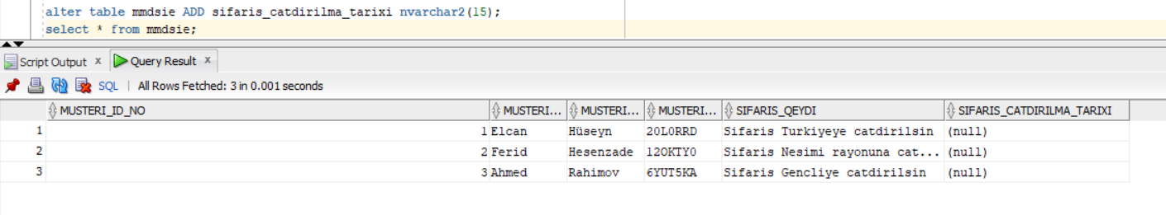

I changed the type of column here to data type:

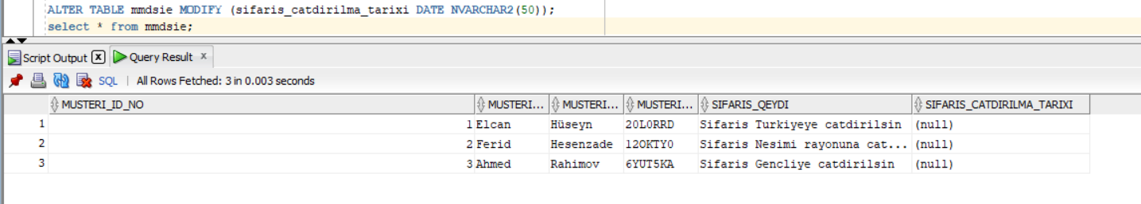

1. Mr I know what is the ‘flashback’ command. But I have a lot of questions about this command.
2. What is the difference between ‘ALTER TABLE old_table_name RENAME TO new_table_name;’ and ‘ALTER TABLE old_table_name RENAME TO new_table_name’
3. How can we insert 20 or more rows fastly?